Engineering a GIS Application: Strategies and Trade-offs
https://medium.com/@Nima-Hmz/engineering-a-gis-application-strategies-and-trade-offs-7670db98910c

Introduction
This is a documentation of strategies used to optimize GIS applications — search, storage, caching, and query performance — based on my experience building a GIS application.

It can work as a starting point or checklist for building a GIS application: a way to see, upfront, what you'll need to think about and decide on before you hit these problems yourself.

It helped me a lot. I hope it helps you too.

Also, the code behind some of these examples is open source:
https://github.com/Nima-Hmz/Bouta

Background

Finding the places near a user sounds like a simple problem. Store a latitude and longitude for each location, calculate the distance to every one, and return the closest. It works perfectly with a hundred records. At a few million, the same request becomes slow, expensive, and hard to scale.
This is what makes geographic data different. Location isn't just another field. It changes how the system searches, stores, and computes, and every request has to stay fast while the data keeps growing and changing.
In this doc, I walk through the strategies I found most useful while building an open source GIS project: reducing the search space, caching, query optimization, asynchronous processing, data separation, and reliability. For each one, I focus on the reasoning and the trade-offs, so you can judge which choices fit your own system, whatever tools you use.
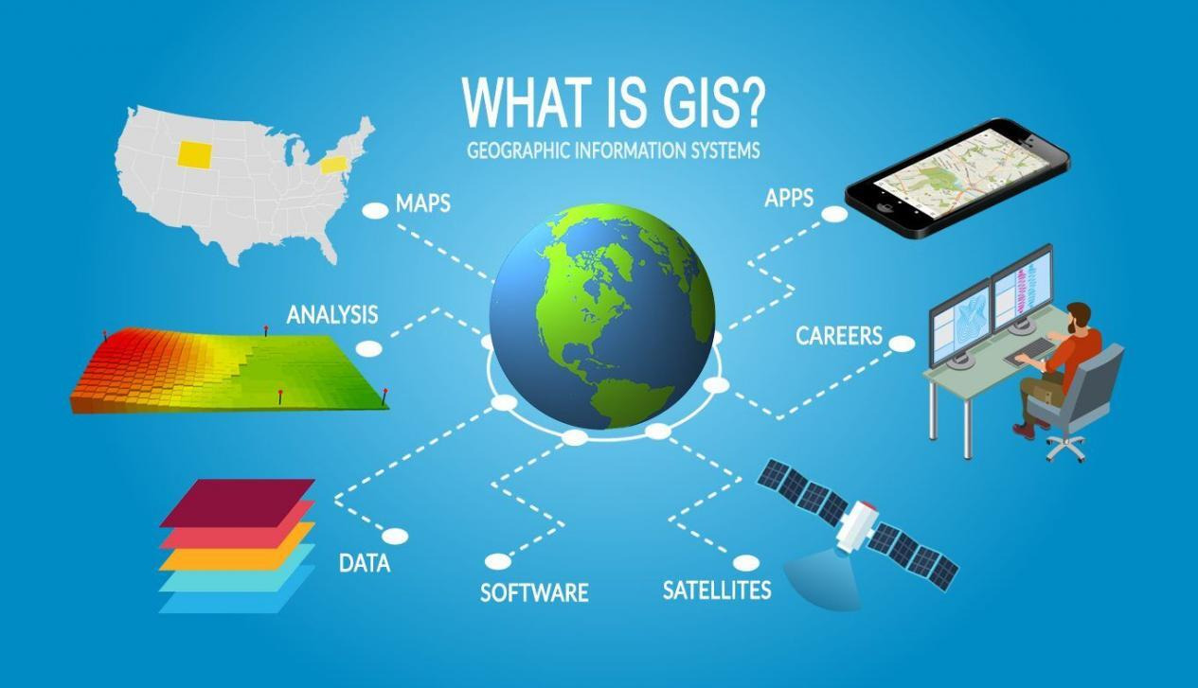
1. Reduce the search space

Imagine you're in London looking for nearby restaurants. If the database holds restaurants from all over the world, the naive approach calculates the distance from you to every one, including places in Istanbul or Tokyo that could never appear in your results. Almost all of that work is wasted, and it grows with every record added.

The real challenge isn't calculating distances accurately. It's reducing how many locations need to be considered in the first place. Five techniques do this, and they work best together.

A) Spatial indexing
Description. A spatial index organizes data by location, so the database can jump straight to the relevant area instead of reading every row, like the index of a book. It's what makes the bounding box filter fast.
Common approaches. There is no single kind of index. Which structures suit you depends on your data and database: R-tree, Quadtree, k-d tree, Grid, geohash, and B-tree variants.
Benefits.
- Searches touch only a small part of the data.
- Query time grows slowly as the dataset grows.
Costs.
- Every insert and update must also update the index.
- It takes extra storage.
- It only helps queries shaped like the ones it was built for. Check your database's query plan to confirm it's being used.

B) Bounding box filtering
Description. Before calculating exact distances, draw a rough rectangle around the search area and discard everything outside it. Only the locations inside get the exact calculation. It's a two-step pattern: a cheap approximate filter first, then an exact one. With a spatial index, the rectangle test doesn't need to scan the whole table.
Benefits.
- Comparing a point to a rectangle is far cheaper than calculating true distance.
- The expensive calculation runs on a small set of candidates.
Costs.
- The rectangle includes corners outside the real radius, so the exact check is still required.
- Building it takes care: a degree of longitude shrinks away from the equator, and areas crossing the edge of the coordinate system need special handling.

C) Partitioning the space
Description. Divide the map into cells, assign each location to one, and search only the user's cell and its neighbors. Cells can be real regions: a user in London searches London and the areas next to it, and restaurants in Istanbul are never touched.
Common approaches.
- Administrative regions (provinces, cities): easy to explain, but populations are uneven.
- Regular grid: simple math and predictable, but no real-world meaning.
- Hierarchical cells: dense areas split into smaller cells, which balances load but adds complexity.
Benefits.
- Whole regions are skipped before any per-location work.
- Real regions match how people think, so the approach is easy to reason about.
- Each cell can be cached or stored on its own.
Costs.
- Cell size is a real decision: too large helps little, too small means touching many cells.
- Load is uneven, so a big city may still need an index and bounding box inside it.
- Users near a border need results from neighboring cells too.
- Every location must be assigned to the right cell, and that assignment must stay correct when data or boundaries change.
D) Filtering on other attributes first
Description. Filtering on non-spatial attributes, like category and status, can remove most records before any spatial calculation runs.
Benefits.
- Simple, and often very effective.
Costs.
- It only helps if the filter is selective.
- The query planner decides the filter order, and extra indexes add write cost.
E) Limiting what's asked for
Description. Cap the search radius, or search only the visible part of the map, so no request grows beyond a reasonable size.
Benefits.
- Every request stays bounded, at almost no cost.
Costs.
- It's a product decision: users can't search arbitrarily far or wide.

2. Avoid repeating work with caching
Now imagine a popular area of London where thousands of users search for restaurants. Each request comes from a different person, but the search areas and parameters are nearly identical, so running the same query every time redoes work that has already been done.
Caching avoids this by storing results and reusing them. Geographic data adds a complication, though: exact coordinates almost never repeat. Two users standing a few meters apart send different requests, so a naive cache rarely gets a hit. Four techniques deal with this.

A) Caching search results
Description. Store the result of a search for a limited time and return it for later requests with the same parameters, instead of running the query again.
Common approaches.
- Application memory: fastest, but each server has its own copy, so results can differ.
- Shared cache: one cache for all servers, at the cost of a network call.
- Edge or CDN layer: served close to the user, which suits responses many users request.
Benefits.
- Fewer database queries and lower load.
- Faster responses, especially in dense areas with overlapping searches.
Costs.
- Cached results can be out of date (see technique D).
- Another component to run and monitor.
- Every request must be turned into a cache key, and a poor key means low reuse (see technique B).
B) Snapping requests to a grid
Description. Since exact coordinates rarely repeat, round each request's location to a cell and use the cell as part of the cache key, so users in the same area share one cache entry.
Common approaches.
- Rounding coordinates: the simplest option. Reduce the precision of latitude and longitude so nearby points collapse to the same value.
- Fixed grid cells: uniform cells, as in partitioning, with one cache entry per cell.
- Administrative regions: cache per city or province, which is intuitive but produces uneven
Benefits.
- A much higher hit rate, since many nearby requests share one entry.
- Cells from partitioning can be reused, so the two strategies support each other.
Costs.
- Precision drops: results are centered on the cell, not the user, so larger cells mean more reuse and less accuracy.
- Users near a cell border may miss nearby places unless neighboring cells are included.
- Cell size is a product decision, since it decides how approximate results can be.

C) Precomputing results
Description. Calculate results ahead of time and store them, so requests simply read them instead of computing on demand.
Common approaches.
- Precomputed map tiles or layers: the map is prepared in pieces, so drawing it means fetching stored tiles.
- Precomputed summaries: counts, densities, or aggregates per area, ready for dashboards and overview maps.
- Scheduled recomputation: results are rebuilt at fixed times, which suits slowly changing data.
Benefits.
- Requests become simple reads, so responses are fast and predictable.
- Heavy computation happens when nobody is waiting.
Costs.
- Storage for everything precomputed, including areas nobody requests.
- Results are only as fresh as the last recomputation.
- It suits stable data. If data changes constantly, recomputing costs more than it saves.
D) Expiry and invalidation
Description. A cache is only useful while its contents are still true. Expiry and invalidation decide when an entry stops being trusted, based on how often the underlying data changes.
Common approaches.
- Time-based expiry: entries live for a fixed period. Simple, but the right period is a guess.
- Invalidate on change: affected entries are removed when data changes. Fresh, but the system must know which entries each change affects.
- A mix: short expiry as a safety net, with invalidation for important changes.
Benefits.
- The cache stays useful without serving results that are too old.
- Expiry can match the data: a rarely changing restaurant list can be cached far longer than live availability.
Costs.
- Too long serves outdated results, too short barely helps.
- Invalidation on change adds complexity, especially across several places.
- When a popular entry expires, many requests can hit the database at once. Staggering expiry times or letting one request rebuild the entry helps.

3. Optimize the work that remains
Even after narrowing the search and avoiding repeated work, every request still has to find candidates, calculate distances, sort them, fetch related data, and build a response. If that work is done carelessly, the request is slow even when the spatial search itself is fast.
Suppose the search finds the right restaurants quickly, but the application then runs an extra query for each result, retrieves fields it never uses, or does work the database could have done. Performance depends on the whole request, not only on the spatial algorithm. Five techniques help here.
A) Nearest-neighbor queries with a limit
Description. "The 10 closest restaurants" and "every restaurant within 5 km, sorted by distance" sound similar but cost very different amounts. The second forces the database to find and sort everything in the area, while the first lets it stop as soon as it has enough results.
Common approaches.
- Radius search with a limit: find places within a distance and return only the first few.
- Nearest-N search: ask directly for the closest N. Some spatial indexes return results already ordered by distance, so no sorting is needed.
- Expanding search: start with a small radius and widen it until enough results are found, which suits areas with uneven density.
Benefits.
- The database can stop early instead of processing every match.
- Result size is bounded, however dense the area.
Costs.
- Ordering by distance directly needs a supporting index, and its distance may be approximate.
- In sparse areas the nearest results may be very far away, so you may still want a maximum radius.
- Expanding searches can mean several queries instead of one.

B) Choosing the right distance calculation
Description. Distance isn't one calculation. The more faithfully you model the Earth's curve, the more each calculation costs, so the right choice depends on how far apart the points are and how precise the answer needs to be.
Common approaches.
- Flat (planar): very cheap, and accurate over short distances in a small area.
- Spherical: treats the Earth as a perfect sphere, a good balance for most applications.
- Ellipsoidal: models the Earth's real shape, the most accurate and the most expensive.
Benefits.
- A cheaper calculation is much faster when it runs on many candidates.
- Precision is spent only where users can notice it.
Costs.
- Flat calculations distort over long distances and large areas.
- The most accurate method costs more than most searches need.
- If a cheap method filters and a precise one ranks, results near the filter's edge can differ between the two steps.
C) Simplifying geometry
Description. A detailed shape, like a coastline or city boundary, can contain thousands of points, which is wasteful to store, calculate with and send when the user is looking at a zoomed-out map. Simplifying reduces the number of points while keeping the overall shape.
Common approaches.
- Simplify at request time: flexible, but costs computation on every request.
- Precomputed versions per zoom level: fast, but takes extra storage.
- Store full detail, cache simplified copies: the original stays the source of truth, which ties back to caching.
Benefits.
- Smaller responses and faster rendering.
- Cheaper calculations on shapes with fewer points.
Costs.
- Detail is lost, and very small features can disappear.
- Shapes simplified separately may stop lining up along shared borders.
- Simplified geometry shouldn't be used for exact calculations, so the original must be kept.
D) Bulk retrieval and fetching only what's needed
Description. Once the right places are found, their related data has to be retrieved. Fetching it one record at a time, or pulling every field when the response needs three, multiplies the cost of every request.
Common approaches.
- Join in a single query: the database combines related data as it finds the results.
- Two steps: find the matching identifiers first, then fetch all their details in one batch.
- Store together what's read together: keep frequently needed fields alongside the location so no extra lookup is needed.
Benefits.
- Far fewer round trips to the database.
- Less data transferred and processed.
Costs.
- Large joins can be slow, and complex queries are harder to maintain.
- Storing data together means duplicating it, and the copies must be kept in sync.
- Fetching only needed fields ties the query to the response, so changing one may require changing the other.
E) Paginating results
Description. Returning every result at once is expensive to produce, send and display. Pagination returns results in chunks, so each request does a bounded amount of work.
Common approaches.
- Offset pages: "skip 20, give me the next 20." Simple, and users can jump to any page.
- Cursor-based paging: "give me the next 20 after this result." Fast on deep pages and better with changing data.
Benefits.
- Every response stays a predictable size.
- Users see the first results quickly.
Costs.
- Offset pages get slower the deeper you go, since the database still steps past everything skipped.
- If data changes between requests, results can be duplicated or missed.
- Cursor-based paging can't jump directly to page 50.
The strategies in sections 1 through 3 exist because location is a different kind of data — they wouldn’t make sense for a system that isn’t spatial. Sections 4 through 6, though, are general engineering concerns: async processing, data separation, and failure planning show up in almost any system at scale, GIS or not. I’m including them because they still show up constantly in a GIS project, and because the spatial techniques above often depend on them — a background job queue is what lets you rebuild a spatial index without blocking requests, for instance. But I’m covering them at a higher level here, since the details are less about geography and more about general system design.
4. Move heavy work out of the request
Some operations are too slow to run while a user waits, such as large imports, assigning regions to new locations, rebuilding aggregates, or generating exports. Run inside the request, they cause spinners, timeouts, and one heavy job slowing everyone else down. Asynchronous processing keeps the request for what the user is waiting on and finishes the rest in the background. Five techniques make this work:
- A) Background job queues: requests enqueue heavy work and return immediately, while separate workers process it.
- B) Scheduled batch processing: expensive recalculations run at set times instead of on every change.
- C) Event-driven processing: changes trigger the follow-up work, so derived data stays close to current.
- D) Making jobs safe to retry: running a job twice leaves the data as if it had run once.
- E) Showing that work is pending: users see the job's status instead of wondering whether something broke.
5. Separate data by how it's used
Not all geographic data behaves the same way. City boundaries change rarely, while a moving vehicle's position changes every few seconds. Some data is read thousands of times per write, and a detailed shape is heavy while a name and category are light. If everything sits together, one set of choices for indexing, caching, and hardware has to serve very different needs. Separating data by how it's used lets each part be handled on its own terms. Five techniques do this:
- A) Separating static from changing data: reference data like boundaries is kept apart from operational data like positions, so each can be indexed and cached to suit it.
- B) Separating geometry from attributes: heavy shapes are stored apart from light fields like name and category, so most requests don't drag the shape along.
- C) Separating hot data from cold data: recent, frequently used data is kept apart from old data, so the active set stays small and fast.
- D) Separating reads from writes: searches go to copies of the data so they don't compete with writes on the main database.
- E) Keeping separated data consistent: once data lives in several places, keeping the copies in agreement needs its own plan.
6. Plan for failure
A system that's fast under normal conditions can still fail under unusual ones. A request for an enormous area, a malformed shape, or a sudden spike of traffic over one popular location can each cost far more than an ordinary request, and every component (database, cache, queue, or copy) can slow down or go away. The earlier strategies make the typical request cheap. This section is about the worst request and the worst day. Five techniques help:
- A) Timeouts and resource limits: every request gets a ceiling on time, data returned, and area covered, so one expensive request can't hurt everyone else.
- B) Validating input: bad coordinates and malformed shapes are rejected at the edge, before they reach the database.
- C) Graceful degradation: when something fails, the system returns a less complete answer instead of an error.
- D) Protecting against overload: rate limits, load shedding, and circuit breakers keep the system responsive during spikes.
- E) Visibility: monitoring and alerts: you can't protect against what you can't see, and monitoring shows whether the other strategies actually work.

Conclusion
Every strategy in this article removes one kind of cost and adds another. There is no free option, so the skill is in choosing the costs your system can afford.
If there's one habit to take away, it's to measure before you optimize. Start with the simplest approach that works, watch where it strains, and add complexity only where the evidence points.
The code behind some of these examples is open source
https://github.com/Nima-Hmz/Bouta

